1. A rigid tank whose volume is 10 L is initially evacuated. A pinhole develops in the wall, and air from the surroundings at 1 bar, 25°C enters until the pressure in the tank becomes 1 bar. No significant heat transfers between the contents of the tank and the surroundings occurs. Assuming the ideal gas model with k = 1.4 for the air, determine (a) the final temperature in the tank, in °C, and (b) the amount of air that leaks into the tank.
2. A rigid tank is divided into two equal parts by a partition. Initially, one side of the tank contains 5 kg of water at 200 kPa and 25°C, and the other side is evacuated. The partition is then removed, and the water expands into the entire tank. The water is allowed to exchange heat with its surroundings until the temperature in the tank returns to the initial value of 25°C. Determine (a) the volume of the tank, (b) the final pressure, and (c) the heat transfer for this process.
3. A piston–cylinder device initially contains air at 150 kPa and 27°C. At this state, the piston is resting on a pair of stops, as shown in Fig., and the enclosed volume is 400 L. The mass of the piston is such that a 350-kPa pressure is required to move it. The air is now heated until its volume has doubled. Determine (a) the final temperature, (b) the work done by the air, and (c) the total heat transferred to block at 80°C is dropped into an insulated tank that contains 0.5 m3 of  
   liquid water at 25°C. Determine the temperature when thermal equilibrium is reached.

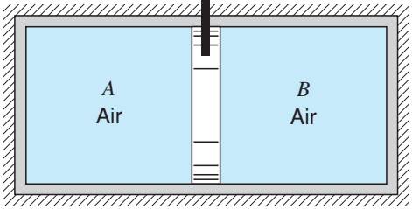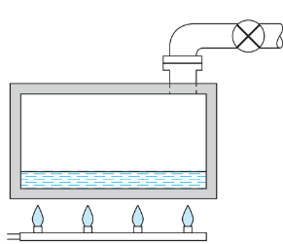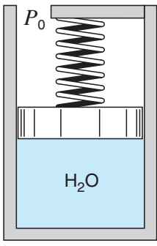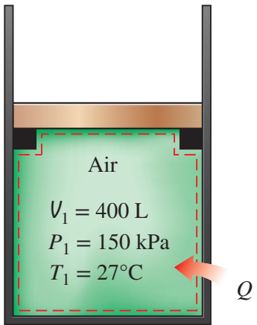Q3 Q4 Q6 Q7

1. A piston/cylinder assembly contains 2 kg of liquid water at 20◦C and 300 kPa, as shown in Fig. P3.48. There is a linear spring mounted on the piston such that when the water is heated, the pressure reaches 3 MPa with a volume of 0.1 m3. a. Find the final temperature. b. Plot the process in a P–v diagram. c. Find the work in the process.
2. A piston/cylinder contains water with quality 75% at 200 kPa. Slow expansion is performed while there is heat transfer and the water is at constant pressure. The process stops when the volume has doubled. How do you determine the final state and the heat transfer?
3. Two kilograms of water at 120◦C with a quality of 25% has its temperature raised 20◦C in a constant volume process as in Fig. What are the heat transfer and work in the process?
4. An insulated cylinder is divided into two parts of 1 m3 each by an initially locked piston, as shown in Fig. Side A has air at 200 kPa, 300 K, and side B has air at 1.0 MPa, 1000 K. The piston is now unlocked so that it is free to move, and it conducts heat so that the air comes to a uniform temperature T A = T B. Find the mass in both A and B and the final T and P
5. Determine the specific volume of refrigerant-134a at 1 MPa and 50°C, using (a) the ideal-gas equation of state and (b) the generalized compressibility chart. Compare the values obtained to the actual value of 0.021796 m3/kg and determine the error involved in each case.
6. A cylinder fitted with a frictionless piston contains butane at 25◦C, 500 kPa. Can the butane reasonably be assumed to behave as an ideal gas at this state?
7. Determine the pressure of water vapor at 315°C and 0.0321 m3/kg, using (a) the steam tables, (b) the ideal-gas equation, and (c) the generalized compressibility chart
8. A well-insulated chamber with V = 1 m3 initially contains air at P = 100 kPa, T = 40oC. Intake and exhaust valves are opened, and air enters and exits at 1 kg/min through each valve. The entering air is at P = 200 kPa, T = 80oC. Assume the air is well mixed so that P and T are uniform throughout the chamber. Find P(t), T(t).

P = 200 kPa

T = 80oC

1 kg/min

Air initially at

P = 100 kPa

T = 40oC

1

2